Build A Web Application Using Node-RED

|  |  |
| --- | --- |
| Date | 1 November 2022 |
| Team ID | PNT2022TMID23506 |
| Project Name | Project – Smart Farmer-IoT Enabled smart Farming Application |

Open a Node-RED

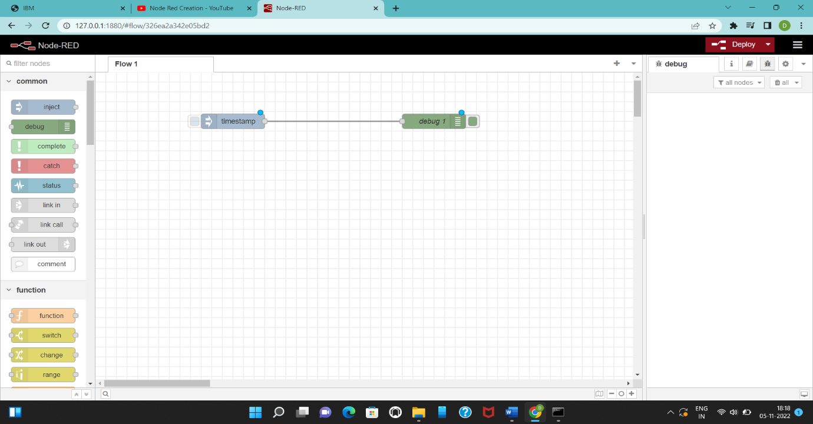

Installing a node-red-contrib-scx-ibmiotapp and node-red-dashboard

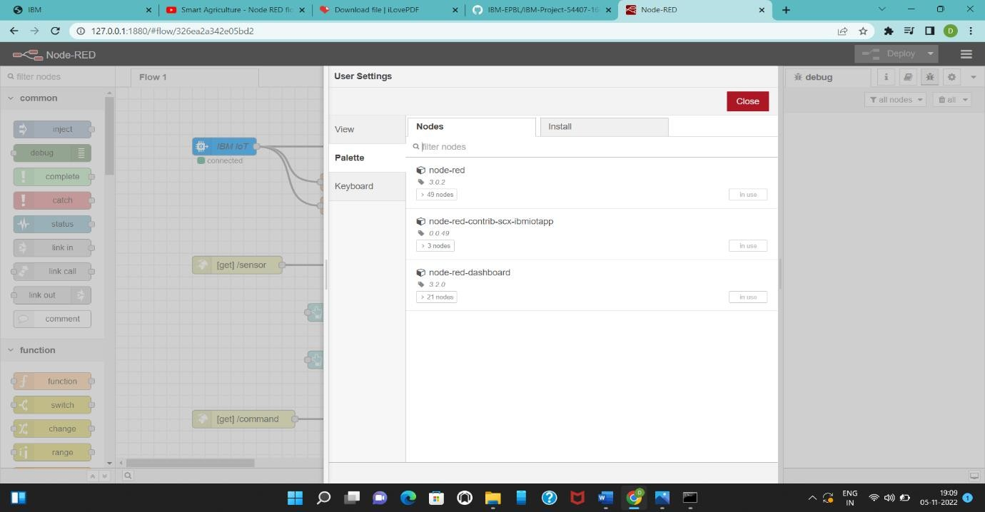

Designing A Web Application

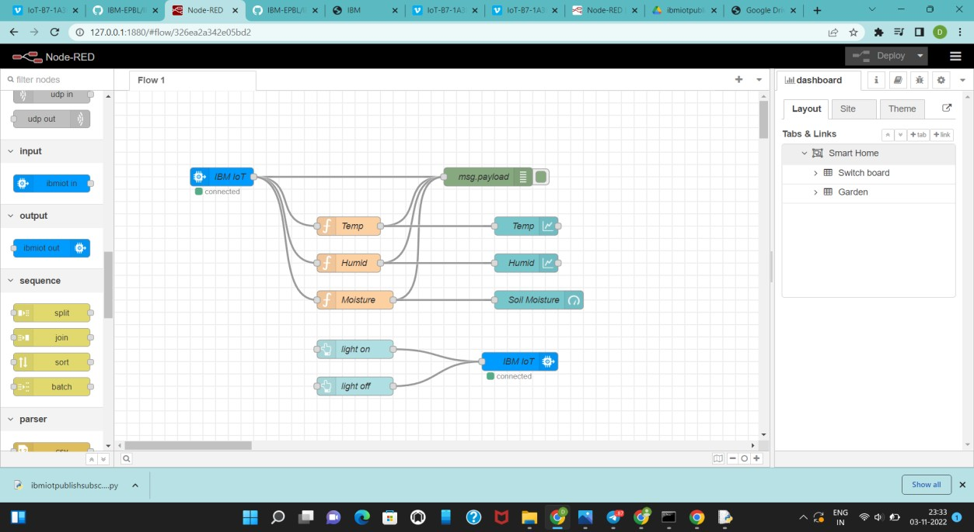

Checking IoT sensor using command in Node-RED

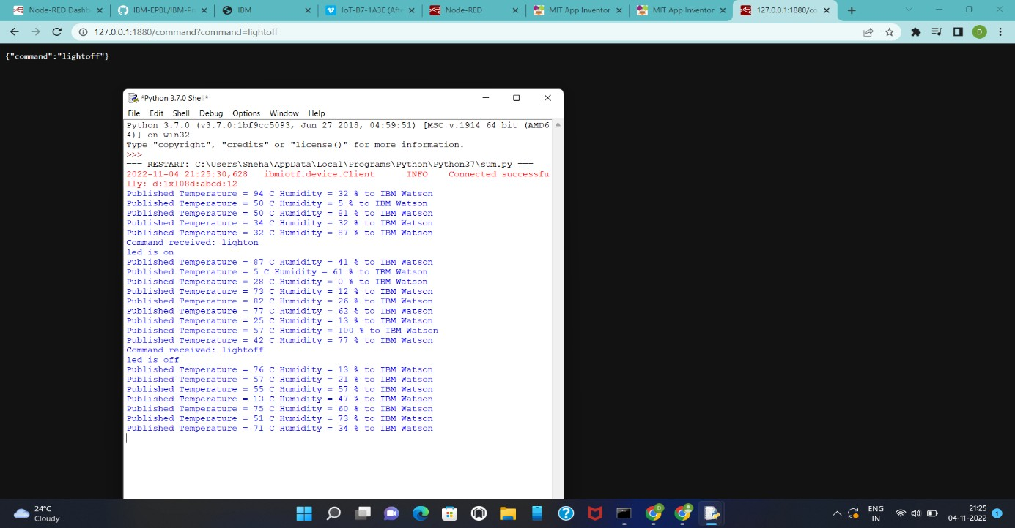

Output in Node-RED Dashboard

